St Andrew's Church

Orford with Longford
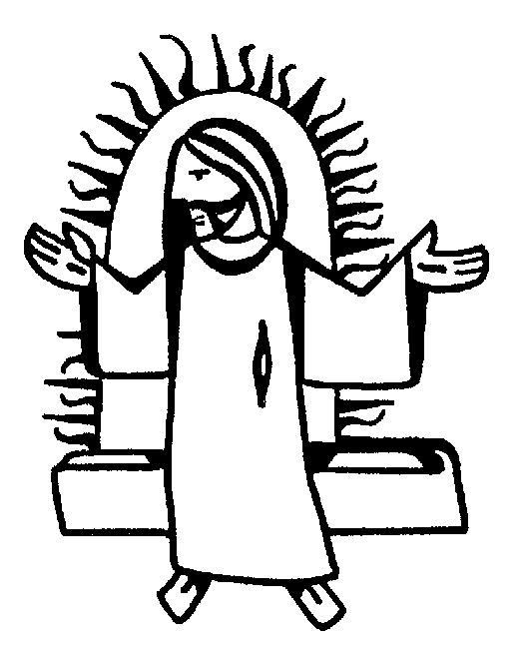

THE FUNERAL SERVICE

for

AUSTIN THOMPSON

Jesus said, “I am the resurrection and I am the life; those who believe in me, though they die, yet shall they live, and whoever lives and believes in me shall never die.”

Reception into Church
Monday 17th August 2009

The priest leads the procession into church, reading the sentences from scripture.

Please stand until Austin’s family have taken their place, then sit or kneel for the service.

Introduction and opening words

Priest: In the name of the Father, and of the Son, and of the Holy Spirit. Amen

We receive the body of our brother Austin with confidence in God, the giver of life, who raised our Lord Jesus from the dead.

Sprinkling the coffin with water

The coffin is sprinkled with holy water taken from the font. It is a reminder of baptism and the promise of eternal life that flows from it.

Priest: With this water we call to mind Austin’s baptism. As Christ went through the deep waters of death for us, so may he bring us to the fullness of resurrection life with Austin and all the redeemed.

The Paschal Candle is lit to remind us of our Lord’s victory over the power of death.

Priest: Jesus Christ is the light of the world
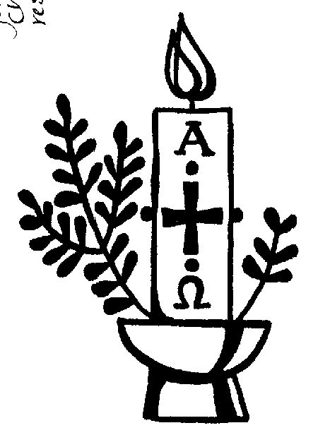
All: a light no darkness can quench

Priest: Stay with us, Lord, for it is evening:
All: and the day is almost over

Priest: Even the darkness is not dark for you:
All: and the night shines like day

Priest: Let your light scatter the darkness:
All: and fill your church with your glory

A reading from the letter to the Romans (verses from chapter 8)

I consider that our present sufferings are not worth comparing with the glory that will be revealed in us. If God is for us, who can be against us? He who did not spare his own Son, but gave him up for us all – how will he not also, along with him, graciously give us all things? Who will bring any charge against those whom God has chosen? It is God who justifies. Who is he that condemns? Christ Jesus, who died – more than that, who was raised to life – is at the right hand of God and is also interceding for us. Who shall separate us from the love of Christ? Shall trouble or hardship or persecution or famine or nakedness or danger or sword? No, in all these things we are more than conquerors through him who loved us. For I am convinced that neither death nor life, neither angels nor principalities nor powers, neither the present nor the future, neither height nor depth, nor anything else in all creation, will be able to separate us from the love of God that is in Christ Jesus our Lord.

This is the word of the Lord
All: Thanks be to God

Verses from Psalm 27

All say together:
1. The Lord is my light and my salvation
whom then shall I fear?
the Lord is the stronghold of my life
of whom shall I be afraid?

4. One thing I have asked from the Lord which I will require
that I may dwell in the house of the Lord
all the days of my life

5. to see the fair beauty of the Lord:
and to seek his will in the temple.

6. For he will hide me under his shelter in the day of trouble
and conceal me in the shadow of his tent
and set me high upon a rock.

8. And I will offer sacrifices in his sanctuary with exultation:
I will sing, I will sing praises to the Lord.

Glory to the Father and to the Son:
and to the Holy Spirit:
As it was in the beginning is now:
and shall be for ever. Amen

The Prayers

Priest: Let us pray:

Prayers for Austin, his family and friends follow.

The Lord’s Prayer:

Priest: Let us pray for the coming of the Kingdom in the words our Saviour gave us:
All: Our Father, who art in heaven,
hallowed be thy name,
Thy kingdom come, thy will be done,
on earth, as it is in heaven.
Give us this day our daily bread,
and forgive us our trespasses,
as we forgive those who trespass against us.
And lead us not into temptation,
but deliver us from evil.

For thine is the kingdom,
the power and the glory,
for ever and ever. Amen.

Hymn During the hymn, a pall is spread over the coffin. Please remain kneeling to sing:

Glory to thee, O God,
for all thy saints in light,
who nobly strove and conquered in the well-fought fight.
Their praises sing,
who life outpoured
by fire and sword for Christ their king.

Thanks be to thee, O Lord,
for saints thy Spirit stirred
in humble paths to live thy life and speak thy word.
Unnumbered they,
whose candles shine
to lead our footsteps after thine.

Lord God of truth and love,
"thy kingdom come", we pray;
give us thy grace to know thy truth and walk thy way:
that here on earth ~
thy will be done,
till saints in earth and heaven are one.

Priest: On Mount Zion the Lord will remove the pall of sorrow hanging over all nations. He will destroy death for ever. He will wipe away the tears from every face.

A Bible may be placed on the coffin, with these words
Lord Jesus Christ, your living and imperishable word brings us to new birth. Your eternal promises to us and to Austin are proclaimed in your Holy Word.

A cross may be placed on the coffin, with these words
Lord Jesus Christ, for love of Austin and each one of us you bore our sins on the cross.

Priest: Let us pray:

We are already God’s children, but what we shall be has not yet been revealed. Yet we know that when Christ appears we shall be like him, for we shall see him as he is.

Keep watch, dear Lord, with those who work, or watch, or weep this night, and give your angels charge over those who sleep. Enfold in your loving arms our brother Austin who now rests in your eternal peace, and give him rest, this night and always. Amen

Rest eternal grant unto him O Lord
All: And let light perpetual shine upon him. Amen

Priest: May Christ, who out of defeat
brought new hope and a new future,
fill you with his light, his love and his new life;
and the blessing of God almighty
the Father, the Son and the Holy Spirit,
be with you tonight and always. Amen

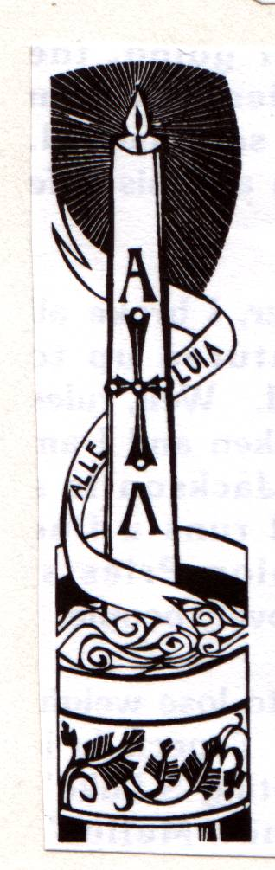

The Requiem

Tuesday 18th August 2009

THE GATHERING

Introit Hymn: “Praise the Lord! Ye heavens adore him”

Praise the Lord! Ye heavens, adore him;
praise him, angels, in the height;
sun and moon, rejoice before him,
praise him all ye stars and light.
Praise the Lord! For he hath spoken;
worlds his mighty voice obeyed:
laws, which never shall be broken,
for their guidance he hath made.

Praise the Lord! for he is glorious;
never shall his promise fail:
God hath made his saints victorious;
sin and death shall not prevail.
Praise the God of our salvation;
hosts on high, his power proclaim;
heaven and earth and all creation,
laud and magnify his name!

Priest: God so loved the world that he gave his only Son, so that everyone who believes in him may not perish but may have eternal life.

We meet in the name of Jesus Christ, who died and was raised to the glory of God the Father. Grace and mercy be with you
All: and also with you.

We have come here today to remember before God our brother Austin; to give thanks for his life; to commend him to God our merciful redeemer and judge; to commit his body to be buried, and to comfort one another in our grief.

Priest: Let us pray:

Almighty God, you judge us with infinite mercy and justice and love everything you have made. In your mercy turn the darkness of death into the dawn of new life, and the sorrow of parting into the joy of heaven; through our Saviour, Jesus Christ. Amen

Prayers of Penitence

Priest: As children of a loving heavenly Father, let us ask his forgiveness, for he is gentle and full of compassion.

(After a period of silent reflection)
All: Most merciful God, Father of our Lord Jesus Christ, we confess that we have sinned in thought, word and deed. We have not loved you with our whole heart. We have not loved our neighbours as ourselves. In your mercy forgive what we have been, help us to amend what we are, and direct what we shall be; that we may do justly, love mercy, and walk humbly with you, our God. Amen

Priest: Almighty God, who forgives all who truly repent, have mercy upon you, pardon and deliver you from all your sins, confirm and strengthen you in all goodness, and keep you in life eternal; through Jesus Christ our Lord. Amen.

The Collect:

Merciful Father, hear our prayers and comfort us; renew our trust in your Son, whom you raised from the dead; strengthen our faith that all who have died in the love of Christ will share in his resurrection; who lives and reigns with you, in the unity of the Holy Spirit, one God, now and for ever. Amen

THE LITURGY OF THE WORD

Please sit for
A reading from the first letter of Peter (1 Peter 1. 3-9)

At the end of the reading
Reader: This is the word of the Lord
All: Thanks be to God

Gradual hymn: (please stand) ‘The Lord’s my shepherd’

The Lord's my Shepherd, I'll not want;
he makes me down to lie -
in pastures green; he leadeth me -
the quiet waters by.

My soul he doth restore again,
and me to walk doth make -
within the paths of righteousness,
e'en for his own name's sake.

Yea, though I walk through death's dark vale,
yet will I fear no ill;
for thou art with me, and thy rod -
and staff me comfort still.

My table thou hast furnished
in presence of my foes;
my head thou dost with oil anoint ,
and my cup overflows.

Goodness and mercy all my life
shall surely follow me;
and in God's house, for evermore
my dwelling place shall be.

THE GOSPEL (please remain standing and face the reader)

Priest: Alleluia, alleluia. God so loved the world that he gave his only Son.
All: Alleluia.

Hear the Gospel of our Lord Jesus Christ according to John (John 6. 35-40)
All: Glory to you, O Lord

Then Jesus declared, "I am the bread of life. He who comes to me will never go hungry, and he who believes in me will never be thirsty. But as I told you, you have seen me and still you do not believe. All that the Father gives me will come to me, and whoever comes to me I will never drive away. For I have come down from heaven not to do my will but to do the will of him who sent me. And this is the will of him who sent me - that I shall lose none of all that he has given me, but raise them up at the last day. For my Father's will is that everyone who looks to the Son and believes in him shall have eternal life, and I will raise him up at the last day."

Priest: This is the Gospel of the Lord
All: Praise to you, O Christ

The Address

The Prayers

Priest: Let us pray

Leader: God of mercy, Lord of life, you have made us in your image to reflect your truth and light: we give you thanks for Austin, for the grace and mercy he received from you, for all that was good in his life and for the memories we treasure today. Especially we thank you for Austin’s faith, courage and love; for all that he has done to build up the life of this church, for his courage and determination in the face of illness, and for his dedication to, and love for, his family. We thank you for the way he has enriched our lives, and that of many others, too.

Leader: Lord in your mercy
All: hear our prayer.

Leader: Heavenly Father, you promised eternal life to those who believe. Remember for good this your servant Austin as we also remember him. Hear our prayers for all who have died, including those we bring to mind today. Bring all who rest in Christ into the fullness of your kingdom where sins have been forgiven and death is no more.

Leader: Lord in your mercy
All: hear our prayer.

Leader: Loving Father, your mighty power brings joy out of grief and life out of death. Look in mercy on Brian, his family and all who mourn at this time. Give them patient faith in times of darkness. Strengthen them with the knowledge of your love.

Leader: Lord in your mercy,
All: hear our prayer.

Leader: Compassionate Father, you are tender towards your children and your mercy is over all your works. Heal the memories of hurt and failure. Give us the wisdom and grace to use aright the time that is left to us here on earth, to turn to Christ and follow in his steps in the way that leads to everlasting life.

Leader: Lord in your mercy,
All: hear our prayer.

All: God of mercy, entrusting into your hands all that you have made and rejoicing in our communion with all your faithful people, we make our prayers through Jesus Christ our Saviour. Amen.

THE LITURGY OF THE SACRAMENT

The Peace (please stand)

Priest: Jesus says: Peace I leave with you; my peace I give to you. Not as the world gives do I give you. Do not let your hearts be troubled, neither let them be afraid. Alleluia.

The peace of the risen Lord be always with you
All: and also with you.

Priest: Let us offer one another a sign of peace.

Everyone is invited to share the peace with one another.

Offertory Hymn: “Jerusalem”

And did those feet in ancient time
walk upon England's mountains green?
And was the holy Lamb of God
on England's pleasant pastures seen?
And did the countenance divine
shine forth upon our clouded hills?
And was Jerusalem builded here
among those dark satanic mills?

Bring me my bow of burning gold!
Bring me my arrows of desire!
Bring me my spear! O clouds, unfold!
Bring me my chariot of fire!
I will not cease from mental fight,
nor shall my sword sleep in my hand,
till we have built Jerusalem
in England's green and pleasant land.

EUCHARISTIC PRAYER E (please kneel)

Priest: The Lord is here.
All: His Spirit is with us.

Priest: Lift up your hearts.
All: We lift them to the Lord.

Priest: Let us give thanks to the Lord our God.
All: It is right to give thanks and praise.

Priest: Blessed are you, gracious God, creator of heaven and earth, giver of life, and conqueror of death. By his death on the cross, your Son Jesus Christ offered the one true sacrifice for sin, breaking the power of evil and putting death to flight. With all your saints
All: we give you thanks and praise.

Priest: Through his resurrection from the dead you have given us new birth into a living hope, into an inheritance which is imperishable, undefiled, and unfading. With all your saints
All: we give you thanks and praise.

Priest: The joy of resurrection fills the universe, and so we join with angels and archangels, with Austin and all your faithful people, evermore praising you and saying:

All: Holy, holy, holy Lord, God of power and might, heaven and earth are full of your glory. Hosanna in the highest. Blessed is he who comes in the name of the Lord. Hosanna in the highest.

Priest: We praise and bless you, loving Father, through Jesus Christ, our Lord; and as we obey his command, send your Holy Spirit, that broken bread and wine outpoured may be for us the body and blood of your dear Son.

On the night before he died he had supper with his friends and, taking bread, he praised you. He broke the bread, gave it to them and said: Take, eat; this is my body which is given for you; do this in remembrance of me.

When supper was ended he took the cup of wine. Again he praised you, gave it to them and said: Drink this, all of you; this is my blood of the new covenant, which is shed for you and for many for the forgiveness of sins. Do this, as often as you drink it, in remembrance of me.

So, Father, we remember all that Jesus did, in him we plead with confidence his sacrifice made once for all upon the cross. Bringing before you the bread of life and cup of salvation, we proclaim his death and resurrection until he comes in glory.

Priest: Praise to you, Lord Jesus:
All: Dying you destroyed our death,
rising you restored our life:
Lord Jesus, come in glory.

Priest: Lord of all life, help us to work together for that day when your kingdom comes and justice and mercy will be seen in all the earth. Look with favour on your people, gather us in your loving arms and bring us with St Andrew and all the saints to feast at your table in heaven. Through Christ, and with Christ, and in Christ, in the unity of the Holy Spirit, all honour and glory are yours, O loving Father, for ever and ever.
All: Amen.

Priest: Let us pray with confidence as our Saviour taught us
All: Our Father, who art in heaven, hallowed be thy name; thy kingdom come; thy will be done; on earth as it is in heaven. Give us this day our daily bread. And forgive us our trespasses, as we forgive those who trespass against us. And lead us not into temptation; but deliver us from evil. For thine is the kingdom, the power and the glory, for ever and ever. Amen.

Priest: Every time we eat this bread and drink this cup,
All: we proclaim the Lord’s death until he comes.

All: Lamb of God, you take away the sin of the world, have mercy on us.
Lamb of God, you take away the sin of the world, have mercy on us.
Lamb of God, you take away the sin of the world, grant us peace.

Priest: Jesus is the Lamb of God who takes away the sin of the world.
Happy are those who are called to his supper.
All: Lord, I am not worthy to receive you, but only say the word and I shall be healed.

Holy Communion is administered at the front of Church. Everyone is warmly invited to receive Holy Communion at this Eucharist. Those who prefer to receive a blessing are also invited to come forward at the same time.

Hymn during Communion:

Abide with me; fast falls the eventide:
the darkness deepens; Lord, with me abide:
when other helpers fail, and comforts flee,
help of the helpless, O abide with me.

Swift to its close ebbs out life's little day;
earth's joys grow dim, its glories pass away;
change and decay in all around I see:
O thou who changest not, abide with me.

I need thy presence every passing hour;
what but thy grace can foil the tempter's power?
Who like thyself my guide and stay can be?
Through cloud and sunshine, Lord, abide with me.

I fear no foe with thee at hand to bless;
ills have no weight, and tears no bitterness,
Where is death's sting? Where, grave, thy victory?
I triumph still, if thou abide with me.

Hold thou thy cross before my closing eyes;
shine through the gloom, and point me to the skies:
heaven's morning breaks, and earth's vain shadows flee;
in life, in death, O Lord, abide with me.

Prayer After Communion:

Priest: Let us pray:

Gracious God, we thank you that in your great love you have fed us with the spiritual food and drink of the body and blood of your Son Jesus Christ and have given us a foretaste of your heavenly banquet: grant that this sacrament may be to us a comfort in affliction and a pledge of our inheritance in that kingdom where there is no death, neither sorrow nor crying, but fullness of joy with all your saints; through Jesus Christ our Saviour. Amen

All: Heavenly Father, in your Son Jesus Christ you have given us a true faith and a sure hope. Strengthen this faith and hope in us all our days, that we may live as those who believe in the communion of saints, the forgiveness of sins and the resurrection to eternal life; through Jesus Christ our Lord. Amen.

Hymn: “The day thou gavest Lord is ended”
(during which the pall is removed)

The day thou gavest, Lord, is ended,
the darkness falls at thy behest;
to thee our morning hymns ascended,
thy praise shall sanctify our rest.

We thank that thy Church unsleeping,
while earth rolls onward into light,
through all the world her watch is keeping,
and rests not now by day nor night.

As o'er each continent and island
the dawn leads on another day,
the voice of prayer is never silent,
nor dies the strain of praise away.

The sun that bids us rest is waking -
our brethren 'neath the western sky,
and hour by hour fresh lips are making -
thy wondrous doings heard on high.

So be it, Lord; thy throne shall never,
like earth's proud empires, pass away;
thy kingdom stands, and grows for ever,
till all thy creatures own thy sway.

The Commendation

Priest: Let us commend Austin to the mercy of God our maker and redeemer.

[Silence is kept]

Priest: God our creator and redeemer, by your power Christ conquered death and entered into glory. Confident of his victory and claiming his promises, we entrust Austin to your mercy in the name of Jesus our Lord, who died and is alive and reigns with you, now and for ever. Amen

The Nunc Dimittis is read as the procession leaves the church.

